**Design and Development of an IoT Based Smart Farming System for Production Of Chillies**

**Aim:**

India is an agricultural country and 70% of the people directly or indirectly depend on agriculture for their livelihood. These days, water scarcity is one of the biggest challenges facing farmers. Another major challenge facing the Indian agricultural sector is the increase in the suicide rate of farmers due to debt. Therefore, effective methods should be used to reduce farming costs and increase agricultural productivity. This research project proposes the development of a standard IoT framework for agricultural productivity by successfully planning irrigation and fertilization based on current crop needs, environmental conditions and climate forecasting. This project proposes the construction of an affordable irrigation system. The proposed fertilizer system distributes the fertilizer to the root directly. This reduces the amount of fertilizer needed and thus reduces costs and improves soil health. An easy-to-use mobile app is designed to bring this information to farmers in their regional language. The standard framework is validated using case studies of chilli cultivation.

**Software & Hardware Components:**

1. Arduino,
2. Relay,
3. Moisture Sensor,
4. Humidity Sensor,
5. Temperature Sensor,
6. Motion Sensor,
7. LCD Display,
8. Wi-Fi,
9. GSM,
10. Power Supply

**Project Flow:**

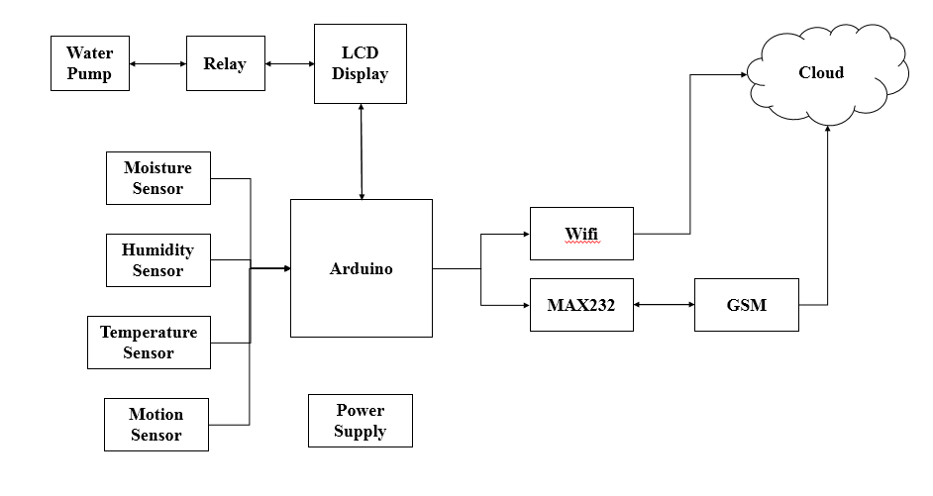

**Proposed Model:**

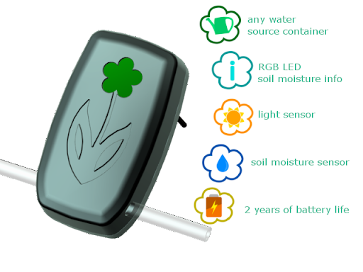

**Stack Holders:**

The first main stack holders would be the consumers like farmers and people who are interested in farming & plant keeping as they can get the daily update about their crops & plants. Not only small consumers many countries and local authorities take part in planting these and also monitor them.

Then comes the commercials who manufacture these prototypes in such a way that they can make it small load purpose and also heavy load which states that the device would be usable for large duties and small duty purposes.

Finally comes the research teams who work on these prototypes and redefine in such a way that they make sure that the prototype is no harm to environment and also affordable to each and every consumers.